**Exercise: The elements of a data story**

**Introduction**

You have gained a thorough understanding of data storytelling, its components and how to craft a compelling story from your raw data. You have learned how a strong narrative drives the storyline while effective visualizations and appropriate charts are at the heart of story presentations and grab the audience’s attention.

In this exercise, you are asked to review the dataset provided, create a narrative story, and present it in the form of a report in Microsoft Power BI. This exercise helps you develop your storytelling skills, which are essential to convey insights effectively.

**Scenario**

Adventure Works, a multinational bicycle manufacturer, has sales operations across the globe. The company’s CEO wants to look at the growth of the company in terms of revenue and profit to devise its strategic directions for future years. That is your narrative.

Follow these exercise steps to craft a compelling data story about the growth of the company.

By completing this exercise, you will demonstrate your ability to:

* Review the dataset and identify the measures needed to support your story.
* Create a multi-page report in Power BI desktop and include appropriate charts that clearly present your data story.
* Identify insights you can convey to the CEO and other stakeholders in your story.

**Step 1: Download the Power BI project file.**

1. Download and save the Power BI project *Adventure Works data story.pbix*.

[Adventure Works data story](https://d3c33hcgiwev3.cloudfront.net/_fZokV-2SwitKjD73m8wlQ_01057e7e085a4ac4b7b2a52bf8d0ace1_Adventure-Works-C6M3L3-Item-05.pbix?Expires=1712361600&Signature=AiNQfee0PPJmLGD9t1PqZv05MJt4YHfK~K08w2yiEQc7qljE-WHli7GWjIlpHbzUlagYF78TaOBfT3f1PmwVF8HXhxbCI6RyyjVhbXjVLqXplYgN1L2I23DFv6NKnNuVTYmuZH2hf7pnwD2DhrgPqERxLtuwq8oJwM5PoKgH30Q_&Key-Pair-Id=APKAJLTNE6QMUY6HBC5A" \t "_blank)

[PBIX File](https://d3c33hcgiwev3.cloudfront.net/_fZokV-2SwitKjD73m8wlQ_01057e7e085a4ac4b7b2a52bf8d0ace1_Adventure-Works-C6M3L3-Item-05.pbix?Expires=1712361600&Signature=AiNQfee0PPJmLGD9t1PqZv05MJt4YHfK~K08w2yiEQc7qljE-WHli7GWjIlpHbzUlagYF78TaOBfT3f1PmwVF8HXhxbCI6RyyjVhbXjVLqXplYgN1L2I23DFv6NKnNuVTYmuZH2hf7pnwD2DhrgPqERxLtuwq8oJwM5PoKgH30Q_&Key-Pair-Id=APKAJLTNE6QMUY6HBC5A" \t "_blank)

2. Open the file in Power BI desktop. Notice that the dataset includes five tables; **Key measures**, **Products**, **Sales**, **Region**, and **Salesperson**.

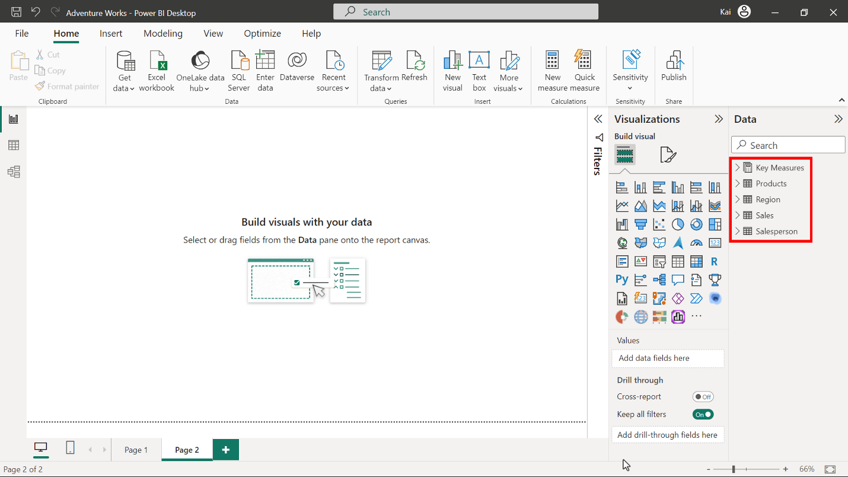

**Step 2: Explore the data and identify which elements you need to visualize.**

1. Explore the dataset tables and measures. Identify which fields and measures you need to include to support your story of growth and which of them you can use to create visualizations in the report canvas.
2. Identify the items from the **Key measures** table that will be the key highlights and the most valuable information for the CEO.

**Tip:** You need to remember the narrative of the story while exploring the data. For example, you can consider **yearly sales** and **previous year sales** to indicate the difference.

**Tip:** You can also consider the **total revenue** and **profit** as the most valuable information and as key highlights of the presentation.

**Step 3: Create a report in Power BI desktop to present your story.**

1. Create a chart showing revenue and revenue from the previous year. Take time to consider the most appropriate chart type for this data before adding it to the canvas.
2. Create another chart showing **Revenue YoY%** which shows the company’s growth over the years in terms of sales.
3. Create visuals to present key information such as profit, revenue, and growth. Again, take time to consider which Power BI visuals you are selecting and why they are the most appropriate.

**Tip:** You can use the **Accessible city park theme** to create consistency in colors.

**Tip:** A bar or column chart are appropriate chart types for revenue and growth analysis.

**Tip:** You can use card visuals to display the key metrics.

**Step 4: Format your visualization and craft the story.**

1. Format the charts for consistent font style, color schemes, and scaling.
2. Organize your findings and highlights on the canvas to structure a coherent narrative.
3. Add a title as the beginning of the story before concluding your story by providing a conclusion or recommendation.

**Tip:** You can add an additional text box at the end of the report to contain the conclusion.

**Tip:** It is good practice to create and format one card visual and then copy and paste it to create others. This ensures a consistent appearance for all the cards.

**Step 5: Provide insights from your data story.**

* Add the insights and takeaways that are evident from your story about Adventure Works growth to the report.

**Tip:** You can write your insights on the same or separate report page.

**Step 6: Save your project.**

* Save your Power BI project to your computer.

**Tip:** Make sure you provide an appropriate path for your project.

**Conclusion**

With these steps you have successfully created a cohesive and informative narrative for the CEO. You identified the most important measures to use as the basis for the visualizations in your report. You then presented these using the most appropriate chart types to display the information. Finally, you were able to present important insights that will assist the CEO in planning for the future.

**Exemplar: The elements of a data story**

**Introduction**

In the exercise *Elements of a data story*, you put into practice your understanding of how to create a data story using Adventure Works’ data in Microsoft Power BI.

  Your objective for this exercise was to complete the following tasks:

* Review the dataset and identify the measures needed to support your story.
* Create a multi-page report in Power BI desktop and include appropriate charts that clearly  present your story.
* Identify and display insights that you can convey to the CEO and other stakeholders in your story.

   This reading provides a step-by-step guide for completing these tasks, accompanied by screenshots for easy comparison with your own copy. You can also review the video [*Storytelling process*](https://www.coursera.org/learn/creative-designing-in-power-bi/lecture/QEi55/the-storytelling-process) and[*Story elements.*](https://www.coursera.org/learn/creative-designing-in-power-bi/lecture/l2NK9/story-elements)

[Adventure Works data story](https://d3c33hcgiwev3.cloudfront.net/_fZokV-2SwitKjD73m8wlQ_01057e7e085a4ac4b7b2a52bf8d0ace1_Adventure-Works-C6M3L3-Item-05.pbix?Expires=1712361600&Signature=AiNQfee0PPJmLGD9t1PqZv05MJt4YHfK~K08w2yiEQc7qljE-WHli7GWjIlpHbzUlagYF78TaOBfT3f1PmwVF8HXhxbCI6RyyjVhbXjVLqXplYgN1L2I23DFv6NKnNuVTYmuZH2hf7pnwD2DhrgPqERxLtuwq8oJwM5PoKgH30Q_&Key-Pair-Id=APKAJLTNE6QMUY6HBC5A" \t "_blank)

[PBIX File](https://d3c33hcgiwev3.cloudfront.net/_fZokV-2SwitKjD73m8wlQ_01057e7e085a4ac4b7b2a52bf8d0ace1_Adventure-Works-C6M3L3-Item-05.pbix?Expires=1712361600&Signature=AiNQfee0PPJmLGD9t1PqZv05MJt4YHfK~K08w2yiEQc7qljE-WHli7GWjIlpHbzUlagYF78TaOBfT3f1PmwVF8HXhxbCI6RyyjVhbXjVLqXplYgN1L2I23DFv6NKnNuVTYmuZH2hf7pnwD2DhrgPqERxLtuwq8oJwM5PoKgH30Q_&Key-Pair-Id=APKAJLTNE6QMUY6HBC5A" \t "_blank)

**Step 1: Download the Power BI project file.**

1. Download and save the Power BI project *Adventure Works data story.pbix*.
2. Open this file in Power BI desktop.

The dataset includes 5 tables: **Key measures**, **Products**, **Sales**, **Region**, and **Salesperson**. The **Key measures** table is not part of the data model. But it does contain the measures for specific business metrics.



Next, you need to explore the dataset tables and measures and identify which fields and measures you need to include that support your story of growth and create visualizations in the report canvas.

The dataset includes four data tables and one measure table. Based on the story narrative, you need to present only the information relevant to company growth in terms of sales and profit. Therefore, plotting yearly sales and the previous year's sales adequately shows the yearly sales data. In addition, you also need to display the year-over-year growth to support your story.

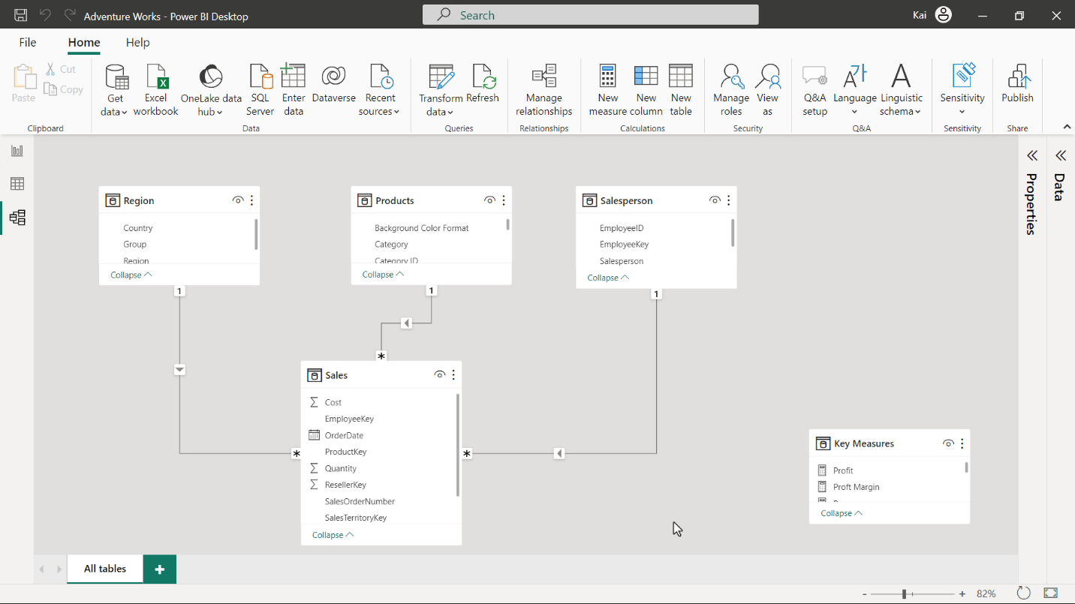

You also need to identify some key highlights from the Key measures table as the most valuable information for the CEO.

Four measures from the key measures table are relevant to the growth story you are going to present. They are **Revenue**, **Revenue YoY%**, **Profit**, and **Profit margin**.

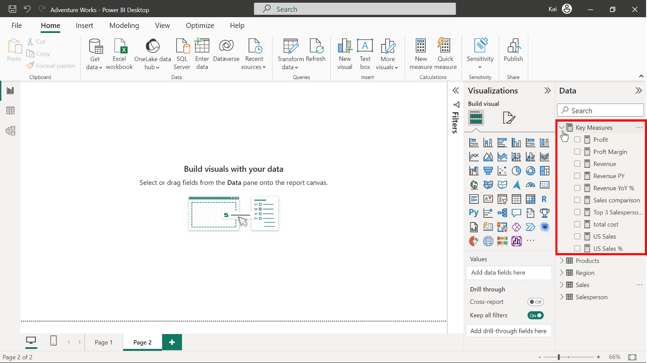

**Step 3: Create a report in Power BI desktop to present your story.**

1. Add a bar or column chart to the canvas to illustrate the comparison of sales for the current year with the previous year. This is the best choice of chart to display the side-by-side comparison.

Before adding further visuals, apply a theme to create consistency in colors and formatting. To match the screenshots used in this reading, select the **Accessible city park theme,** and customize it to display text in a black color.

2. Create another chart showing the company’s sales growth over the years. You can use the same chart type you used in the previous step.  It is an appropriate chart type to represent the date-related data and helps to create a consistent look in the report.

3. You now need to create visuals to present the key information such as profit, revenue, and growth.

The most appropriate visual to show the single data point as valuable information is the card visual. The Power BI core **Visualization pane** offers two types of card visuals that you can use to display this information.

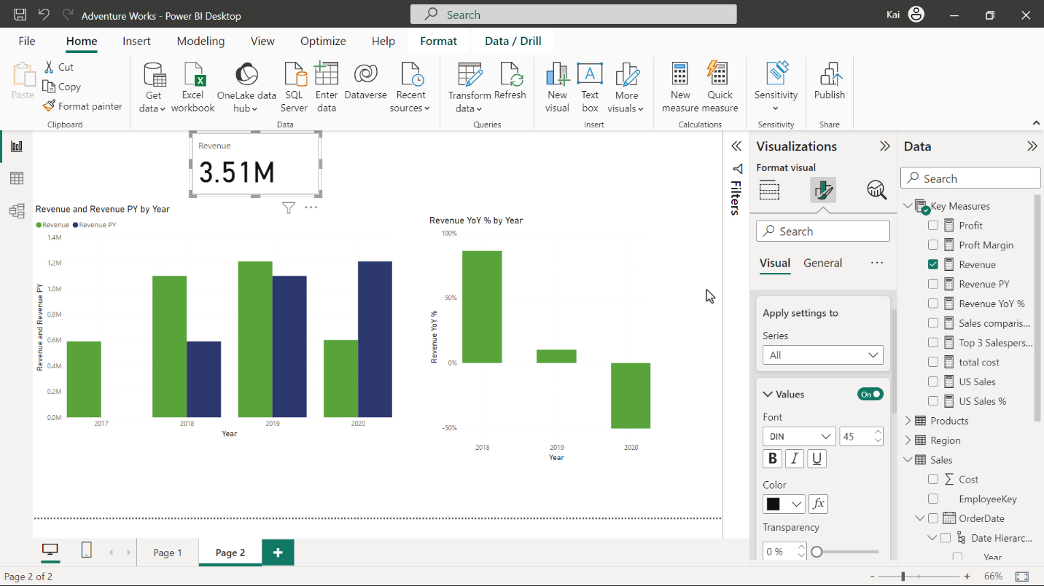

**Step 4: Format your visualization and craft the story.**

1. Format the charts for consistent font style, color schemes, and scaling.

Make sure the axis title, values, and data labels are of the same size and color. A font size of 12 point would be appropriate.

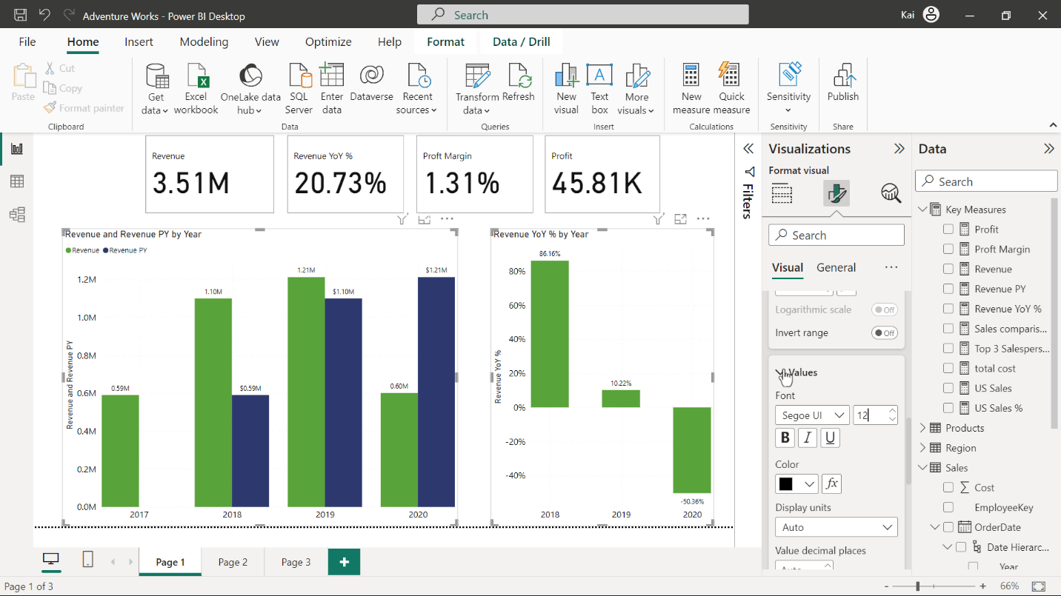

Adjust the titles of the charts if necessary and increase the font size to create a font hierarchy.

Format the card visuals. Resize them to the same size and increase the category font size. You can also create a somewhat more appealing design by changing the background color of the card visuals.

2. Organize your findings and highlights on the canvas to structure a coherent narrative.

Once you format the visual elements of your story, you need to arrange them in a logical sequence on the report canvas, so that the visuals tell the growth story of Adventure Works.

Card visuals represent the key metrics of the company, which you bring on the top of the canvas, followed by the column chart side by side below the card visuals.

3. Add a title that emphasizes the narrative. You can add a text box and write a title - for example, **Navigating growth through the years** - and reposition on the top left of the canvas.

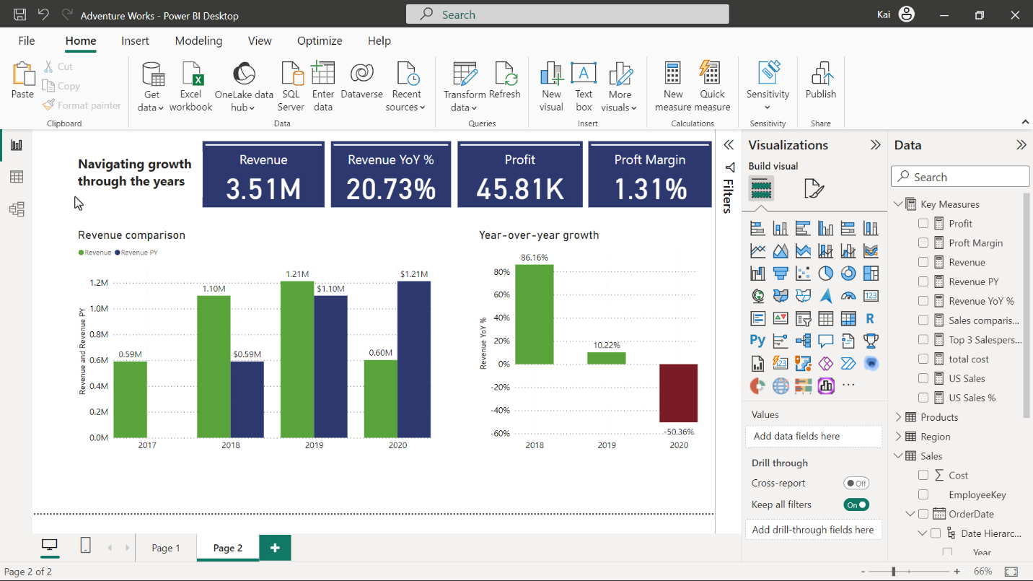

**Step 5: Provide insights from your data story.**

Now you can add a visual to include the insights and takeaways that are evident from your story about Adventure Works' growth.

Add another text box at the bottom of the report canvas to hold your findings.

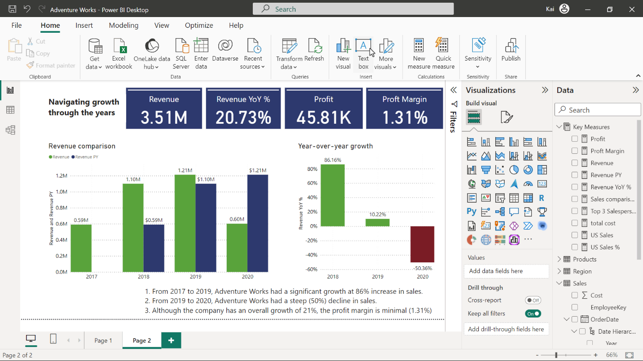

Based on the storyline presented in your report, the key findings that the CEO should now be aware of are:

* From 2017 to 2019, Adventure Works had a significant growth at 86% increase in sales.
* From 2019 to 2020, Adventure Works had a steep (50%) decline in sales.
* Although the company has an overall growth of 21%, the profit margin is minimal (1.31%)

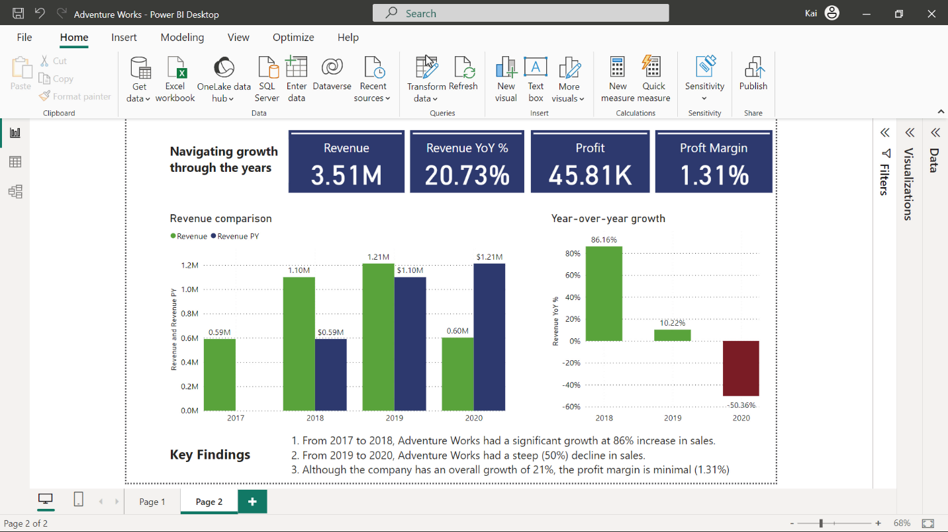

**Step 6: Save your project**

* Save your Power BI project to your computer.

**Tip**: Make sure you provide an appropriate path for your project.

**Conclusion**

You have successfully crafted a data story for Adventure Works’ CEO that is easy to understand and has a clear narrative to show the company’s growth over the years. The appropriate identification of relevant data out of a huge data set, a precise selection of chart type, and a logical arrangement of visual elements on the report canvas help you convey the message via data storytelling to your stakeholders.